Phase 5 – Project Development
1. Project Title
Import Data using Transform Maps (Spreadsheet)

2. Introduction
The Project Development phase describes the implementation of the Import Data using Transform Maps (Spreadsheet) project in ServiceNow.
The project was developed to import employee information from a spreadsheet into ServiceNow using an Import Set and Transform Map. The imported information is mapped to the Employee Test table. Employee ID is used as the Coalesce field to support updating existing records and inserting new records. Reports and an Employee Analytics Dashboards dashboard are also created to analyze the imported employee information.

3. Development Environment
The project was developed using:
Component | Used
Platform | ServiceNow
Data Source | Spreadsheet
Import Method | Import Set
Transformation | Transform Map
Target Table | Employee Test
Reporting | ServiceNow Reports
Dashboard | Employee Analytics Dashboards

4. Employee Test Table Development
The Employee Test table was created as the target table for storing the transformed employee information.
The table contains:
- Employee ID
- Employee Name
- Email
- Department
- Location
The project guide specifies the Employee Test table and these fields.
Screenshot to add
📸 Screenshot 1 – Employee Test Table
Take a screenshot showing your Employee Test table and its fields.
Caption:
Figure 1: Employee Test Table
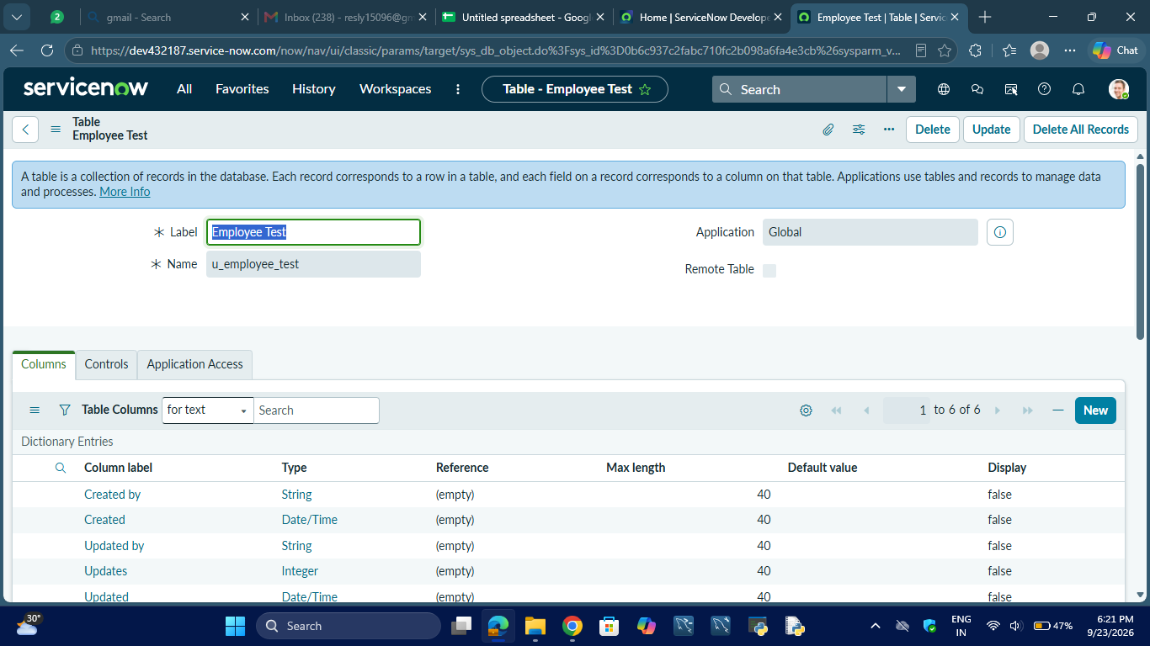

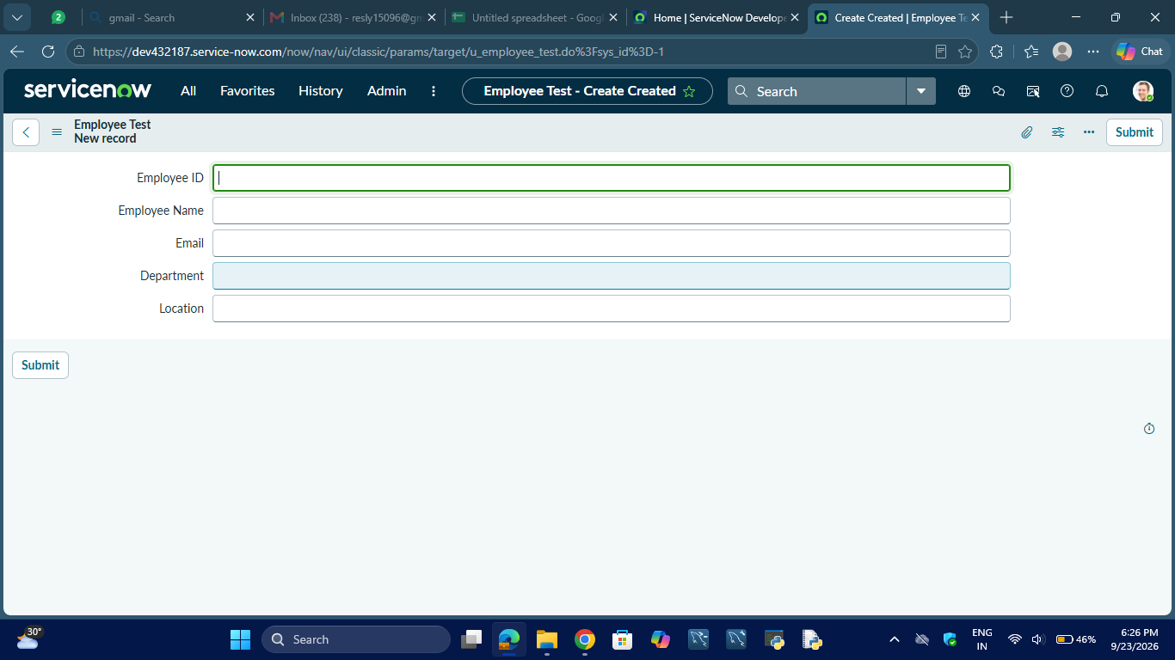

5. Employee Import Development
An Import Set table named Employee Import was created to temporarily store the spreadsheet data before transformation.
The system name generated for the table is:
u_employee_import
Screenshot to add
📸 Screenshot 2 – Employee Import Table
Show the Employee Import table/data.

Caption:
Figure 2: Employee Import Table
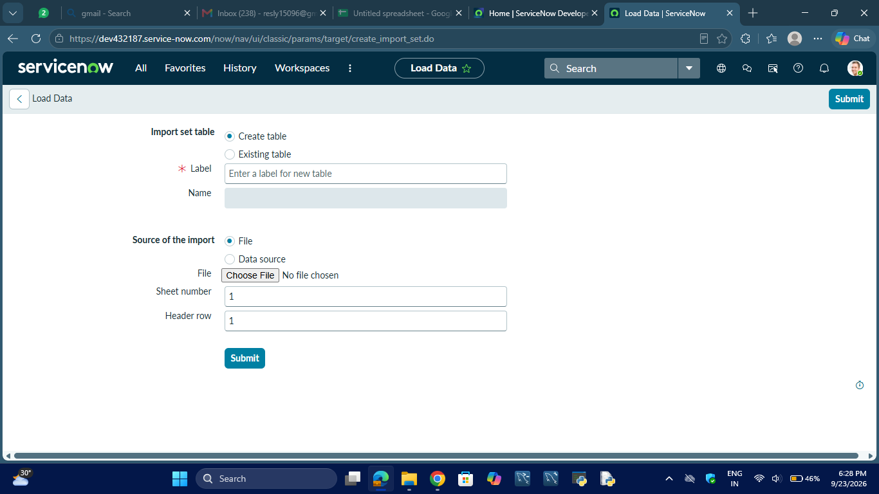

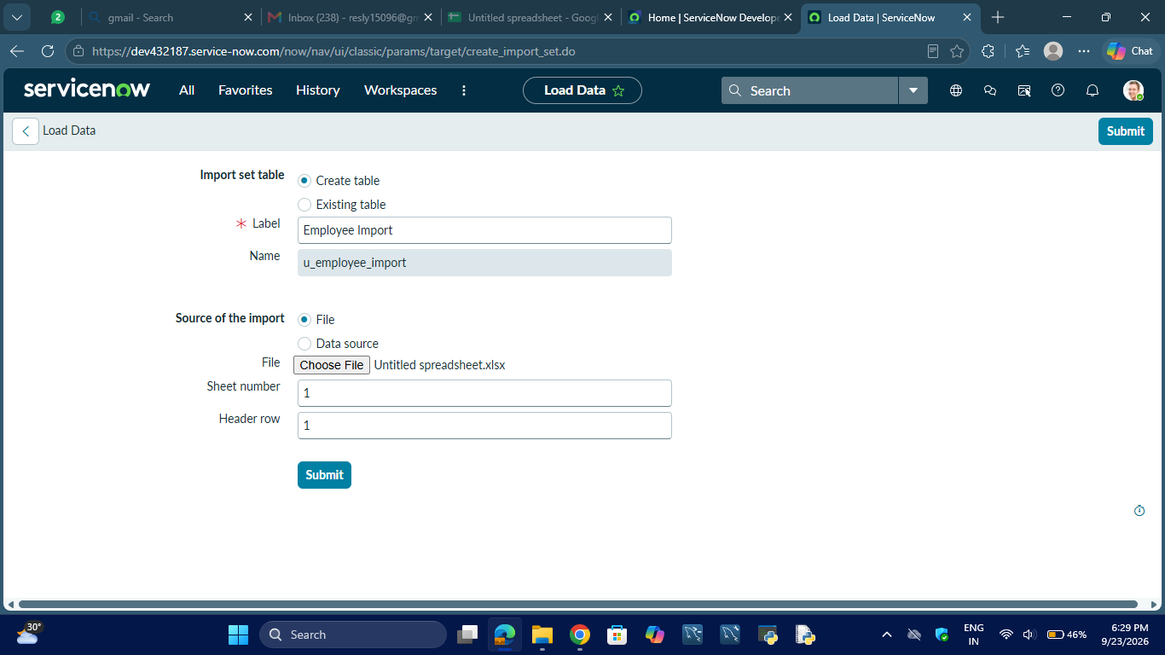

6. Spreadsheet Data Import
The employee spreadsheet was loaded into ServiceNow using the Import Set functionality.
The spreadsheet contains employee information corresponding to the fields in the Employee Test table.
Screenshot to add
📸 Screenshot 3 – Spreadsheet Import
Show the ServiceNow Load Data / Import Set screen or the imported spreadsheet data.
Caption:
Figure 3: Employee Spreadsheet Data Imported into ServiceNow

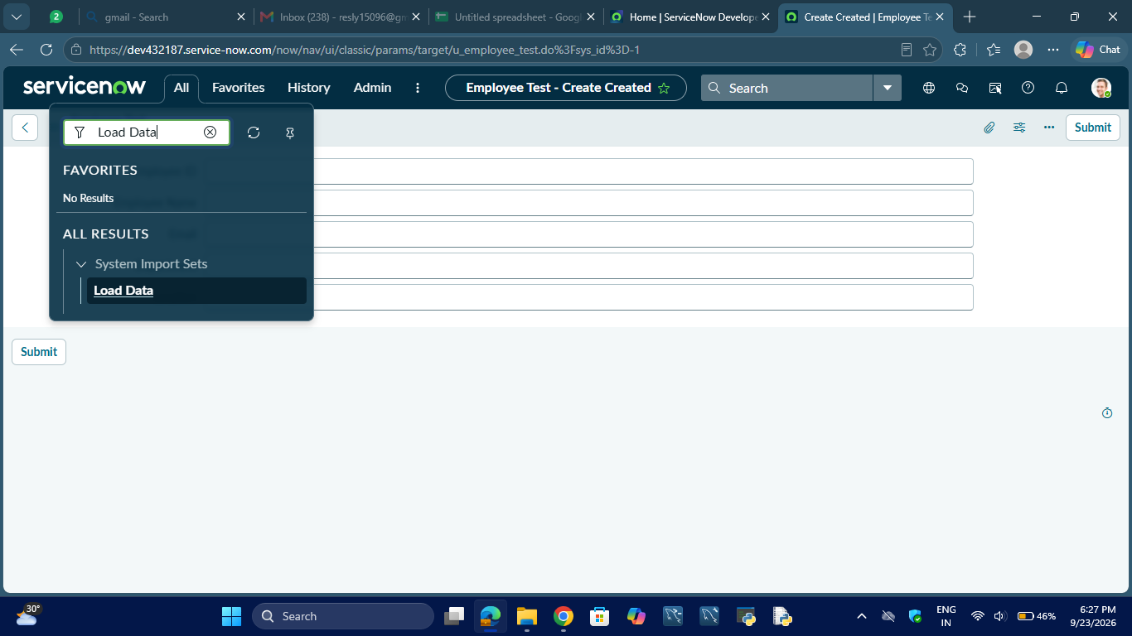

7. Transform Map Development
A Transform Map named:
Sample Spreadsheet Import
was created.
Transform Map Configuration
Property | Value
Name | Sample Spreadsheet Import
Source Table | Employee Import
Target Table | Employee Test

The project guide specifies these Transform Map settings.
Screenshot to add
📸 Screenshot 4 – Transform Map
Show your Sample Spreadsheet Import Transform Map.
Caption:
Figure 4: Sample Spreadsheet Import Transform Map
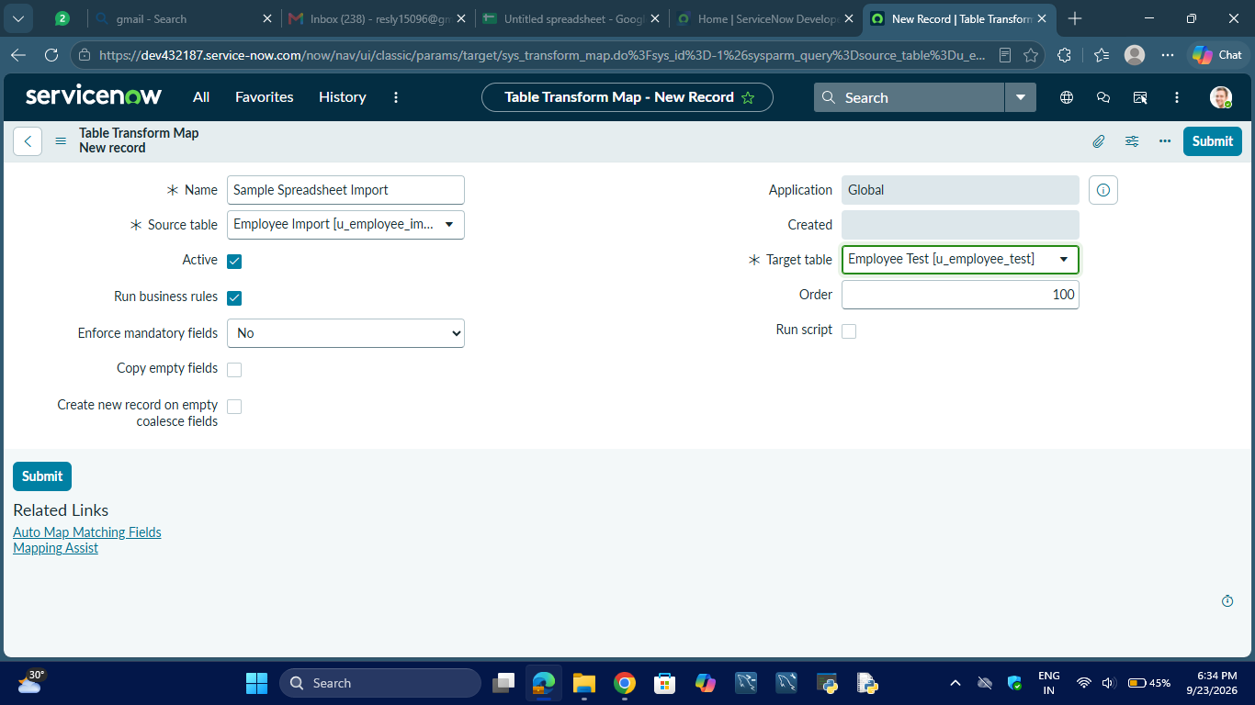

8. Field Mapping Development
The source fields were mapped to the corresponding target fields.
Source Field | Target Field
Employee ID | Employee ID
Employee Name | Employee Name
Email | Email
Department | Department
Location | Location

Screenshot to add
📸 Screenshot 5 – Field Mapping
Show the Field Maps related list or Mapping Assist screen where the mappings are visible.
Caption:
Figure 5: Source-to-Target Field Mapping
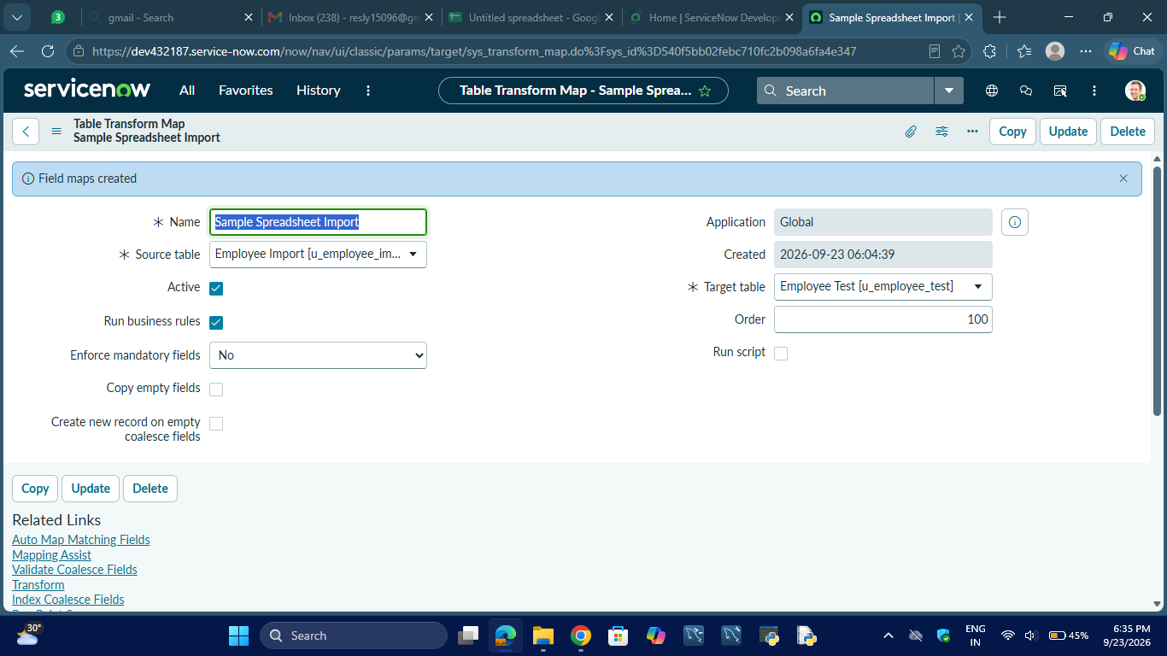

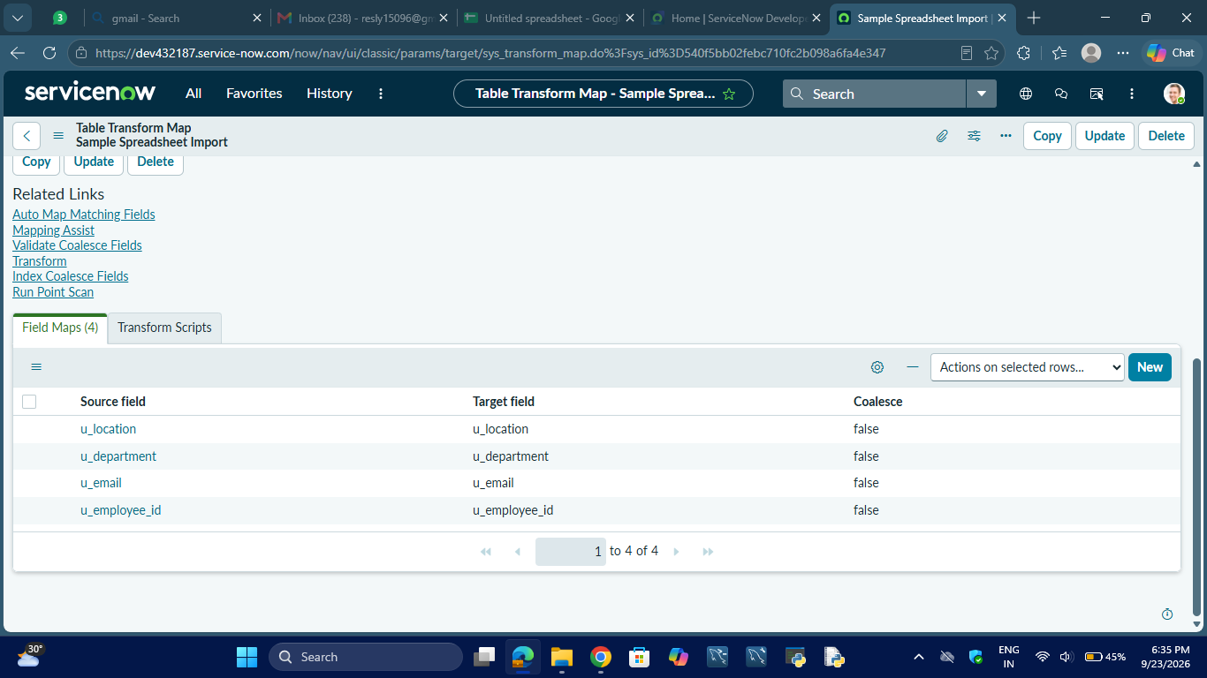
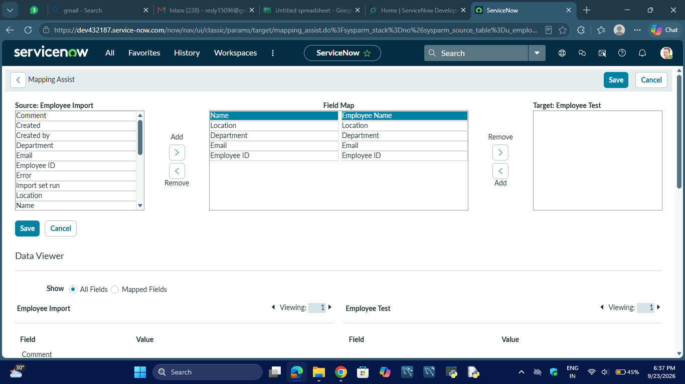

9. Coalesce Configuration
Employee ID was configured as the Coalesce field.
This allows ServiceNow to identify an existing employee record using Employee ID and update it instead of creating a duplicate. New Employee IDs can be inserted as new records.
Screenshot to add
📸 Screenshot 6 – Coalesce Configuration
Show the Field Map where:
Employee ID → Employee ID → Coalesce = True

Caption:
Figure 6: Employee ID Coalesce Configuration
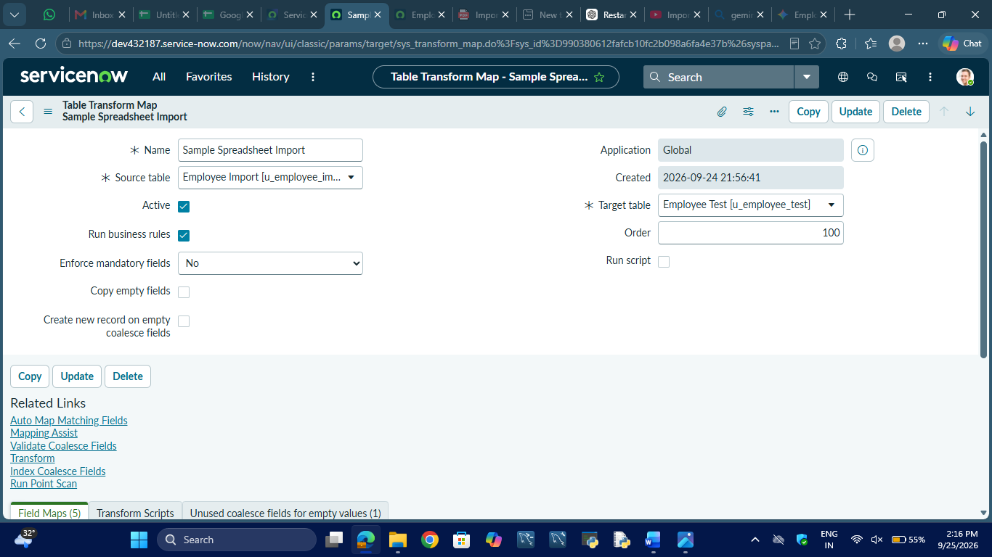

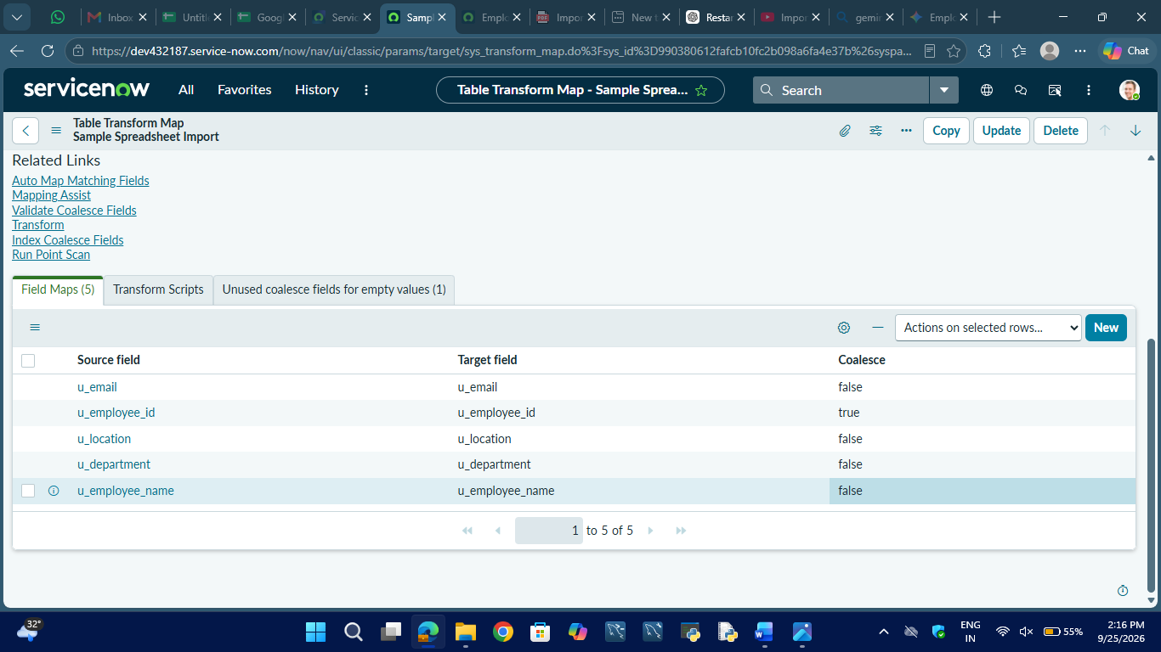

10. Data Transformation
After configuring the Transform Map and field mappings, the employee data was transformed from the Employee Import table into the Employee Test table.
The Transform operation was executed and the resulting records were verified in the target table.
Screenshot to add
📸 Screenshot 7 – Transform Result
Show the successful Transform result/history.
Caption:
Figure 7: Successful Data Transformation
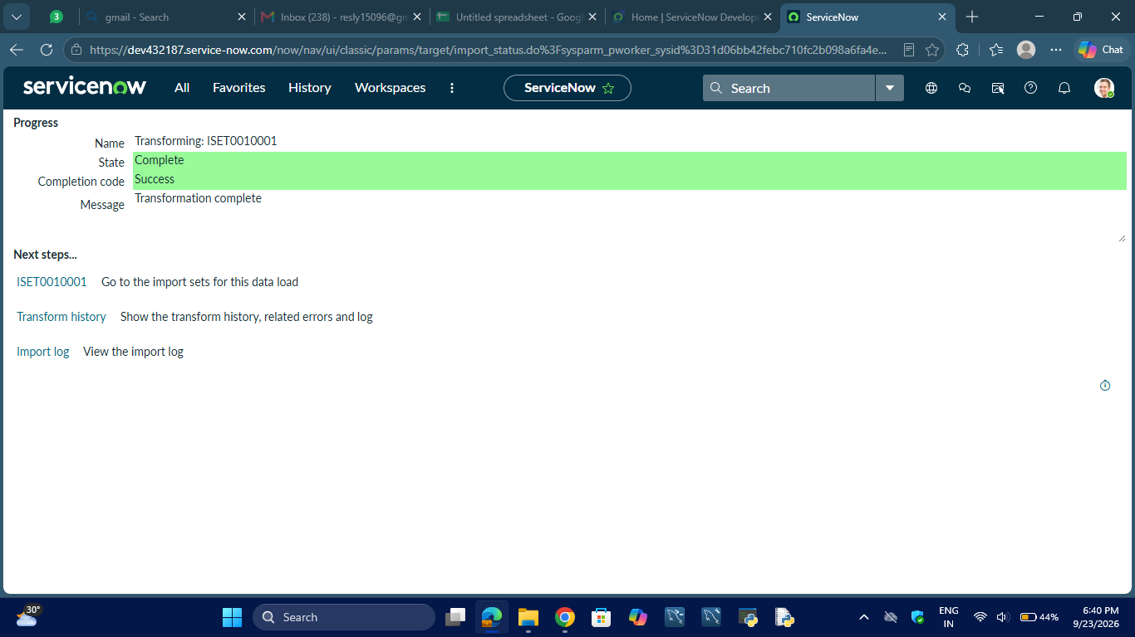

11. Employee Records
After transformation, the employee records were available in the Employee Test table.
Screenshot to add
📸 Screenshot 8 – Employee Test Records
Show the actual employee records in your Employee Test table.
Caption:
Figure 8: Imported Employee Records in Employee Test
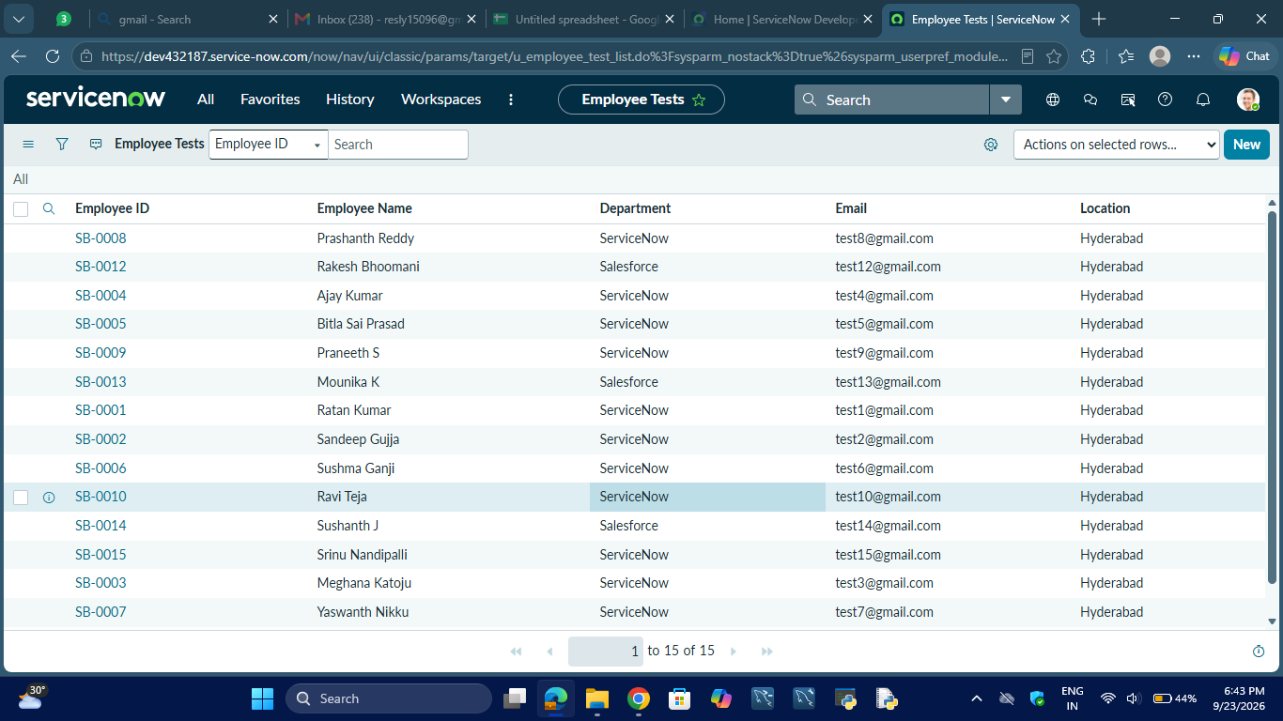

12. Update and Insert Functionality
The Coalesce configuration was tested by importing employee information again.
The system can:
- Update an existing employee when the Employee ID matches.
- Insert a new employee when the Employee ID does not already exist.
The project guide describes re-uploading the same sheet to test the transformation and checking the Transform History for inserted, updated, and ignored records.
Screenshot to add
📸 Screenshot 9 – Transform History
Show the Transform History with the appropriate inserted/updated records.
Caption:
Figure 9: Transform History Showing Data Processing Results
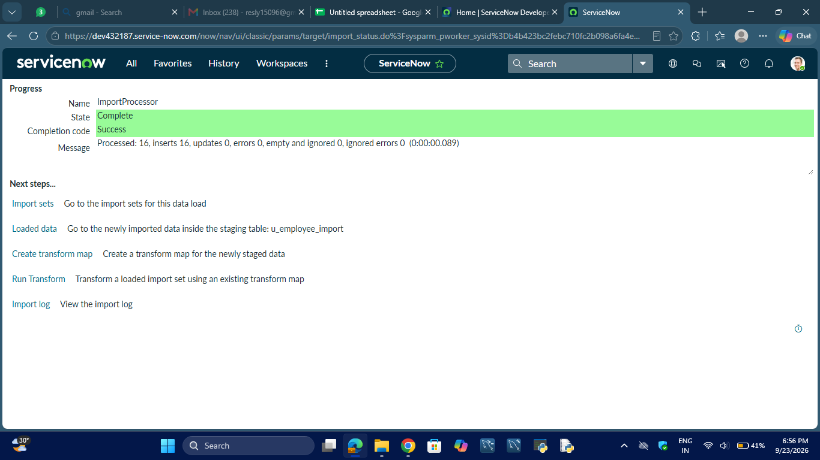

13. Employees by Department Report
A report named Employees by Department was created using the Employee Test table.
Report configuration:
- Source: Employee Test
- Type: Pie Chart
- Group By: Department
- Aggregation: Count
Screenshot to add
📸 Screenshot 10 – Department Report
Show your actual pie chart.

Caption:
Figure 10: Employees by Department Report
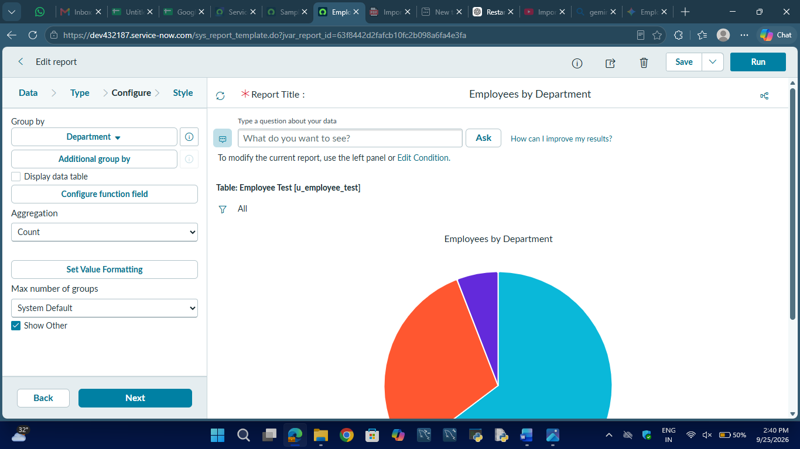

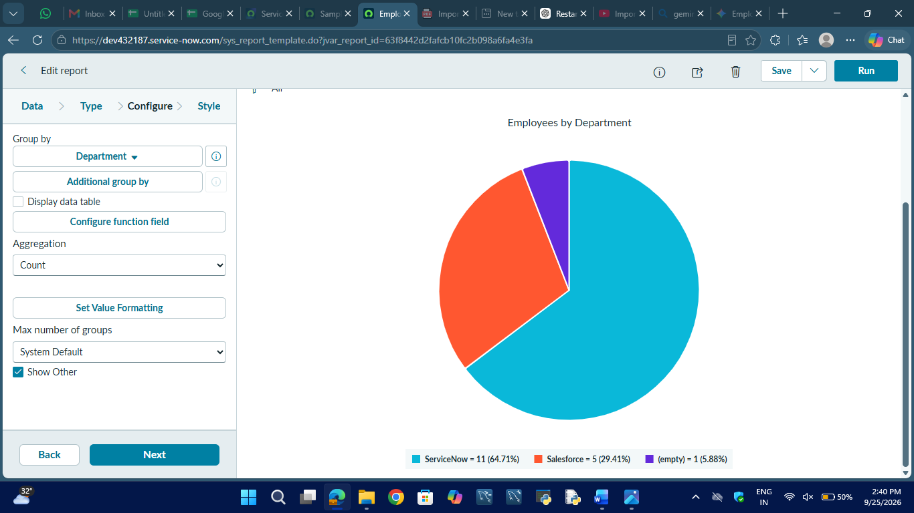

14. Employees by Location Report
A report named Employees by Location was created using the Employee Test table.
Report configuration:
- Source: Employee Test
- Type: Bar Chart
- Group By: Location
- Aggregation: Count
Screenshot to add
📸 Screenshot 11 – Location Report
Show your actual bar chart.
Caption:
Figure 11: Employees by Location Report
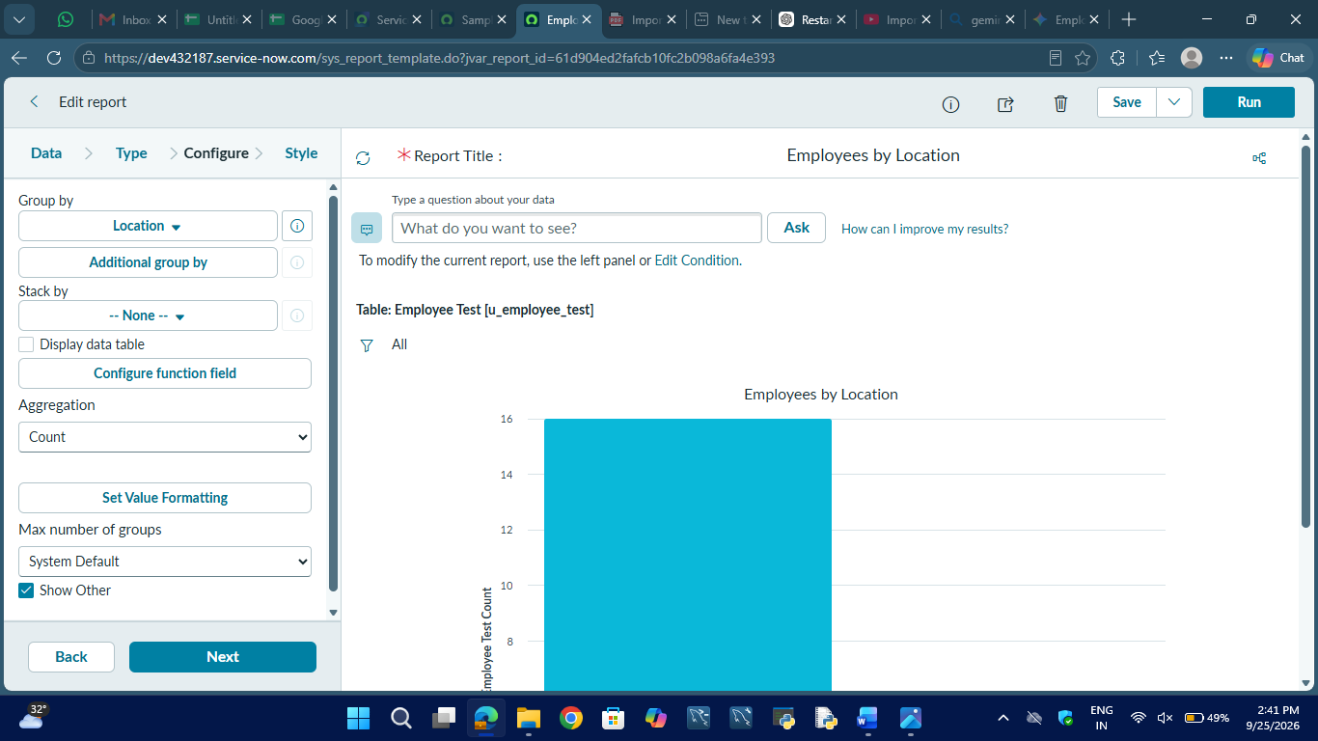
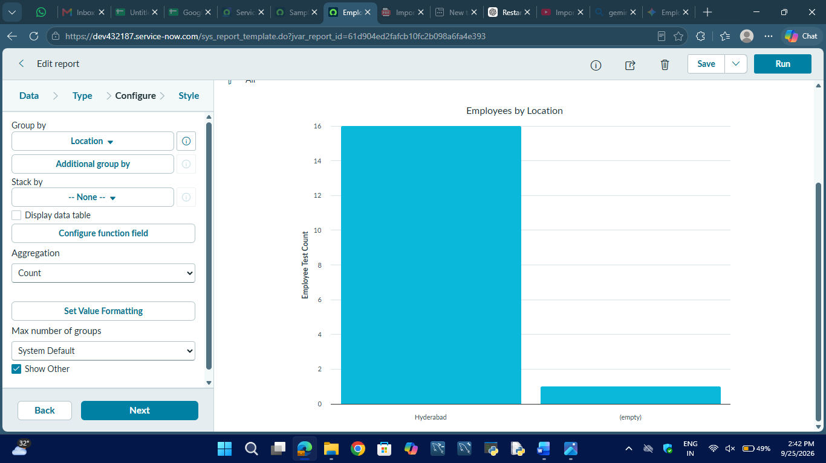

15. Employee List Report
An Employee List Report was created to display the employee records.
The report contains:
- Employee ID
- Employee Name
- Email
- Department
- Location
Screenshot to add
📸 Screenshot 12 – Employee List Report
Show your actual list report.

Caption:
Figure 12: Employee List Report
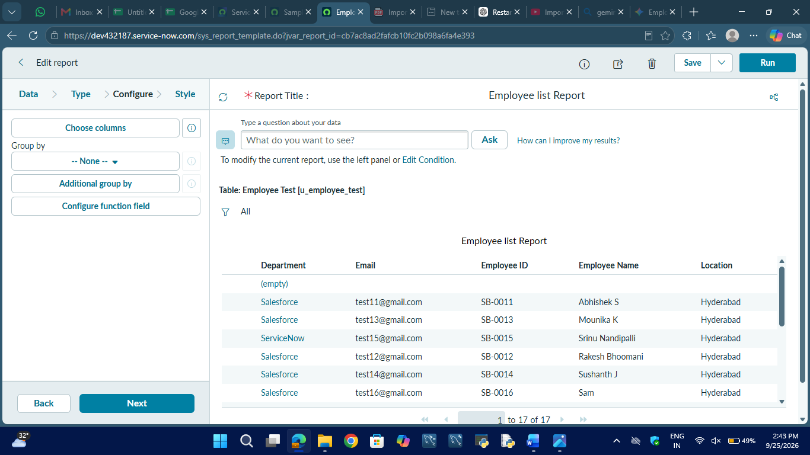

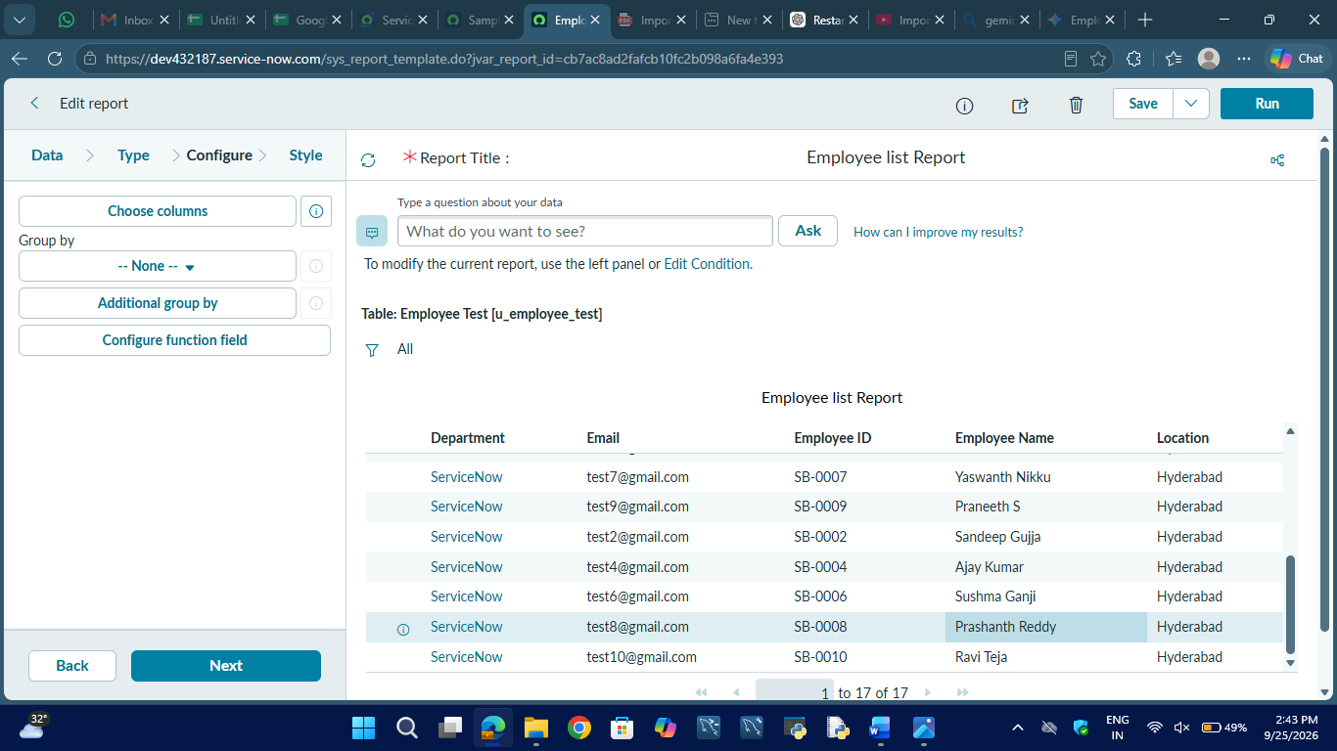

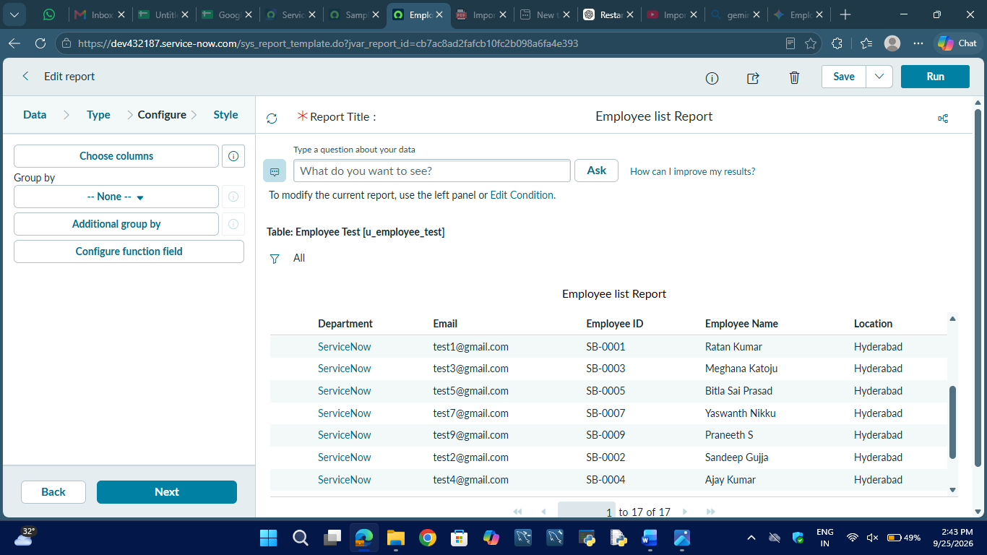

16. Employee Analytics Dashboard
The three reports were added to the:
Employee Analytics Dashboards
dashboard.
Screenshot to add
📸 Screenshot 13 – Final Dashboard
Show the complete dashboard containing your three reports.

Caption:
Figure 13: Employee Analytics Dashboards
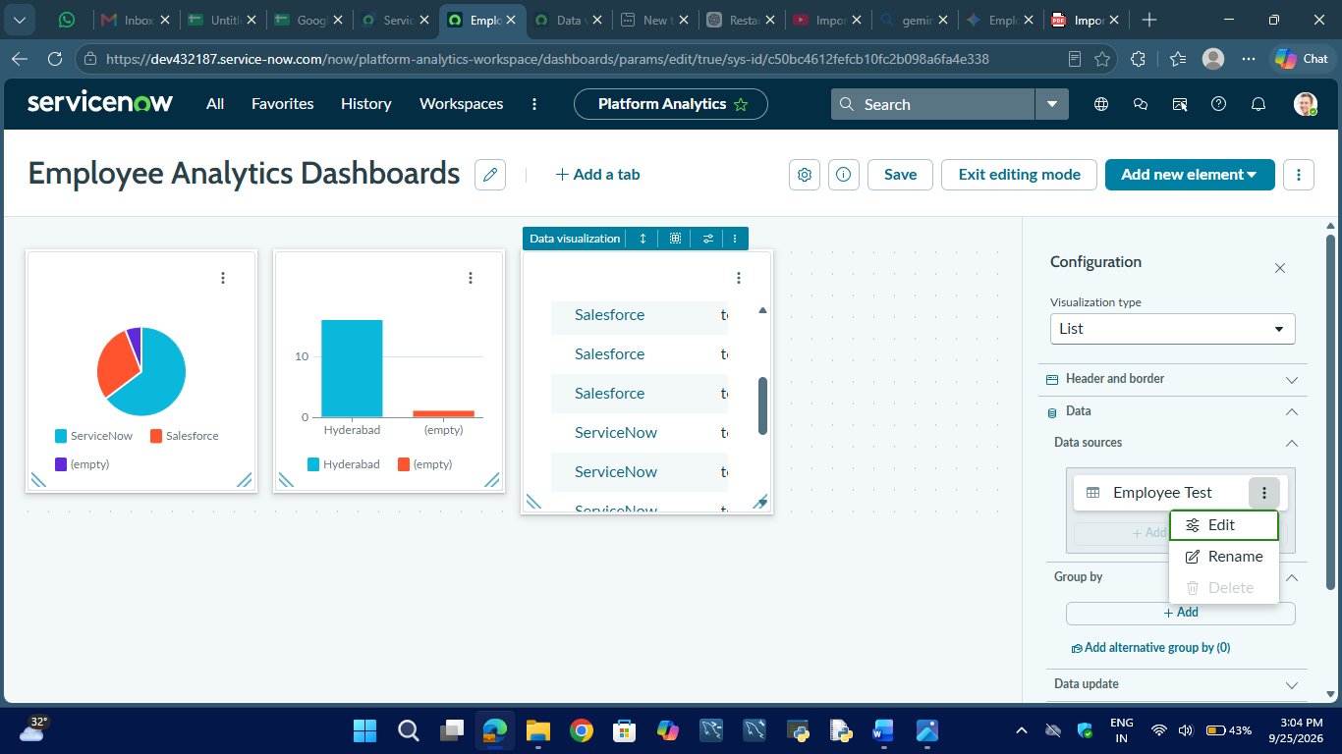

17. Final Development Workflow
The completed development process is:
Employee Spreadsheet
↓
Employee Import
↓
Sample Spreadsheet Import
↓
Field Mapping
↓
Employee ID Coalesce
↓
Data Transformation
↓
Employee Test
↓
Reports
↓
Employee Analytics Dashboards

18. Development Summary
The project was successfully developed in ServiceNow using Import Sets and Transform Maps. The Employee Import table was used as the staging table, while Employee Test was used as the target table. The source fields were mapped to the corresponding target fields, and Employee ID was configured as the Coalesce field.
The imported employee information was then used to create department, location, and employee list reports, which were added to the Employee Analytics Dashboards.

